**Question 1: Write a program that reads the following data into a 2D array of doubles. Display the array, multiply it by 2, and display it again.**

//summary: this program displays an array with set values, doubles them, and displays it again

//name: Jenna Wolf

//class: Computer Science II, CS-265

//instructor: Mr. Waleed Amer

//date: 01/29/2023

public class Main {

public static void main(String[] args) {

double[][] array = { {1.1, 2.2, 3.3}, {4.4, 5.5, 6.6}, {7.7, 8.8, 9.9} }; //holds the array data

//displays the array

for(int i = 0; i < 3; i++) {

for(int j = 0; j < 3; j++)

System.out.print(array[i][j] + " ");

System.out.println();

}

System.out.println();

//doubles all values in the array

for(int i = 0; i < 3; i++) {

for(int j = 0; j < 3; j++)

array[i][j] = array[i][j] * 2;

}

//dispalys the array

for(int i = 0; i < 3; i++) {

for(int j = 0; j < 3; j++)

System.out.print(array[i][j] + " ");

System.out.println();

}

}

}

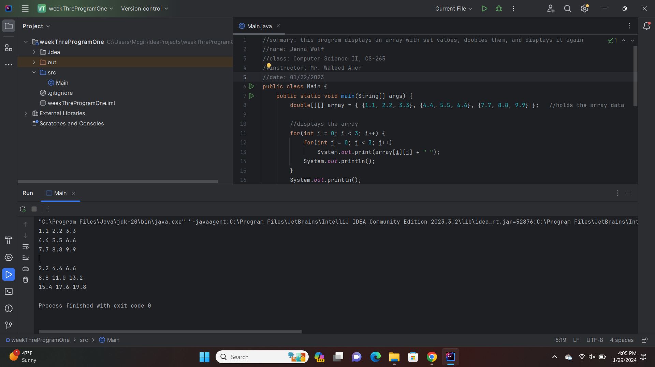

**Question 2: Write a program to ask the user for the size of the 2D double array, then prompt the user to enter values to fill the array. Finally the program will print the content to screen.**

//summary: this program takes in the size of a 2D array from the user, lets them fill it, and prints it

//name: Jenna Wolf

//class: Computer Science II, CS-265

//instructor: Mr. Waleed Amer

//date: 01/29/2023

import java.util.Scanner;

public class Main {

public static void main(String[] args) {

Scanner input = new Scanner(System.in); //names the input

int col = 0, row = 0; //holds the col and row data

//gets the row and column size from the user

System.out.print("Enter your row size: ");

row = input.nextInt();

System.out.print("Enter your column size: ");

col = input.nextInt();

double[][] array = new double[row][col]; //creates an array of size row and col

//gets the array data from the user

System.out.println("Please enter the values for the array");

for(int i = 0; i < row; i++) {

for(int j = 0; j < col; j++)

array[i][j] = input.nextDouble();

}

//prints the array

System.out.println();

for(int i = 0; i < row; i++) {

for(int j = 0; j < col; j++)

System.out.print(array[i][j] + " ");

System.out.println();

}

}

}

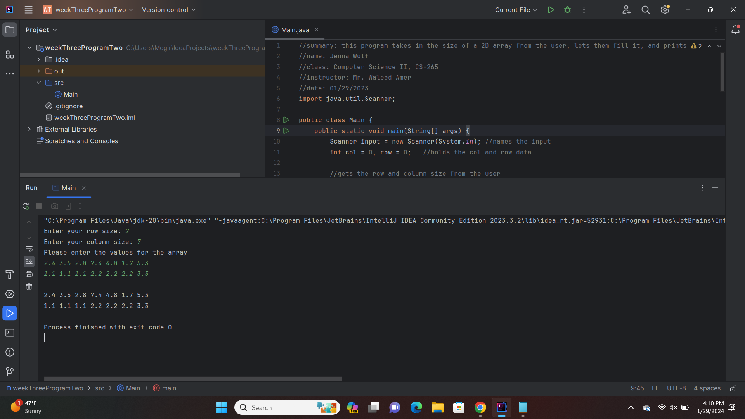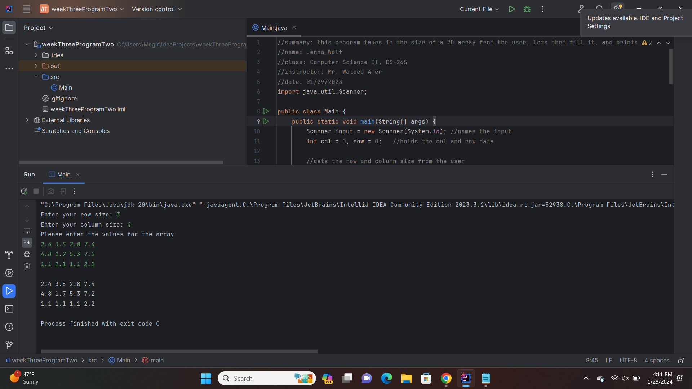

**Question 3: Write a program to sum all the elements in a two-dimensional array of doubles of size 3x3 and produce one value. The program will ask the user to enter the content of the array.**

//summary: this program lets the user fill the array. It then sums all numbers in the array.

//name: Jenna Wolf

//class: Computer Science II, CS-265

//instructor: Mr. Waleed Amer

//date: 01/29/2023

import java.util.Scanner;

public class Main {

public static void main(String[] args) {

Scanner input = new Scanner(System.in); //names the input

double[][] array = new double[3][3]; //holds the array data

double sum = 0; //holds the sum data

//fills the array with users input

System.out.println("Please enter your values to fill the 3x3 array");

for(int i = 0; i < 3; i++) {

for(int j = 0; j < 3; j++)

array[i][j] = input.nextDouble();

}

//sums together all array values

for(int i = 0; i < 3; i++) {

for(int j = 0; j < 3; j++)

sum += array[i][j];

}

//displays the array and the sum of all numbers

for(int i = 0; i < 3; i++) {

for(int j = 0; j < 3; j++)

System.out.print(array[i][j] + " ");

System.out.println();

}

System.out.println("Sum of the numbers of the array is " + sum);

}

}

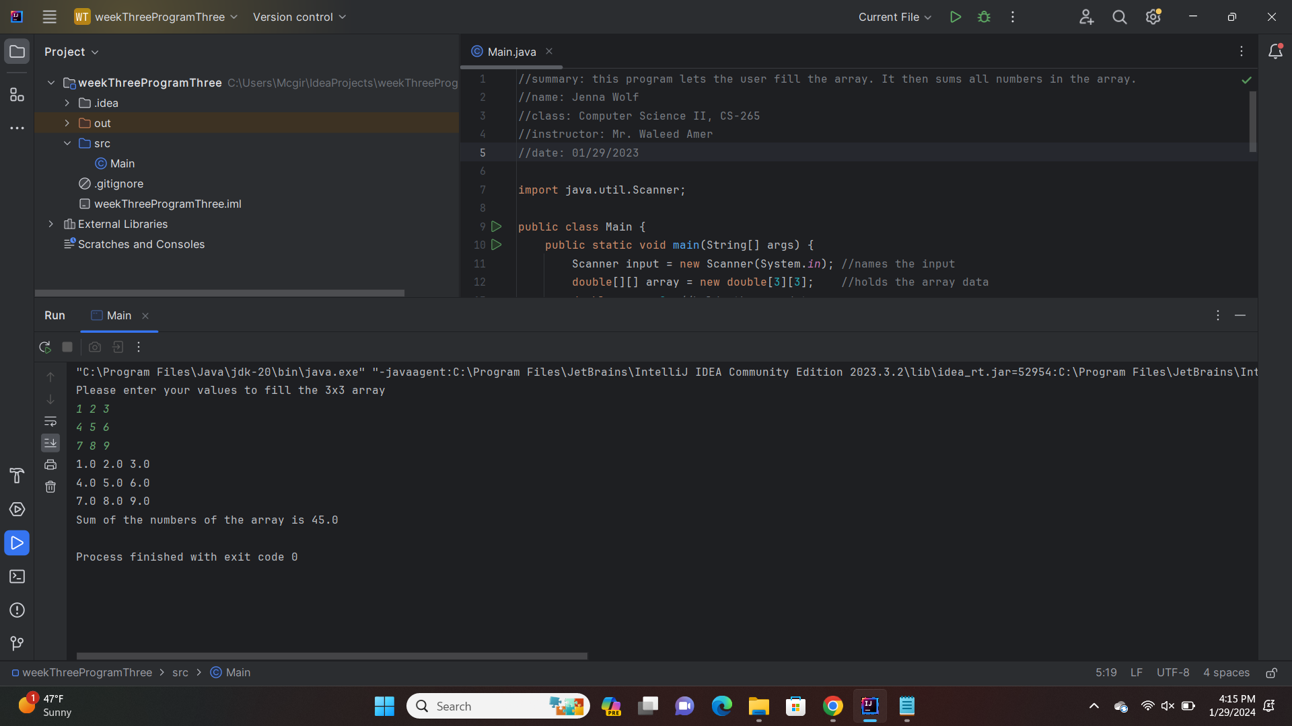

**Question 4: Write a program to sum, subtract, multiply and divide the content of two 2x2 matrices and store the result in a third matrix. Then print the content of the third matrix. The array will hold double numbers.**

//summary: this program allows a user to fill 2 2x2 arrays. It then finds the sum of those arrays and

//displays it. It does the same thing for difference, product, and quotient

//name: Jenna Wolf

//class: Computer Science II, CS-265

//instructor: Mr. Waleed Amer

//date: 01/29/2023

import java.util.Scanner;

public class Main {

public static void main(String[] args) {

Scanner input = new Scanner(System.in); //names the input

double[][] A = new double[2][2]; //holds the A data

double[][] B = new double[2][2]; //holds the B data

double[][] C = new double[2][2]; //holds the C data

//gets the user input for the A array

System.out.println("Enter the content for the first array:");

for(int i = 0; i < 2; i++) {

for(int j = 0; j < 2; j++)

A[i][j] = input.nextDouble();

}

//gets the user input for the B array

System.out.println("Enter the content for the second array:");

for(int i = 0; i < 2; i++) {

for(int j = 0; j < 2; j++)

B[i][j] = input.nextDouble();

}

//gets the sum of the two arrays for each cell

for(int i = 0; i < 2; i++) {

for(int j = 0; j < 2; j++)

C[i][j] = A[i][j] + B[i][j];

}

//displays the last array

System.out.println("C array: ");

for(int i = 0; i < 2; i++) {

for(int j = 0; j < 2; j++)

System.out.print(C[i][j] + " ");

System.out.println();

}

//gets the user input for the A array

System.out.println("Enter the content for the first array:");

for(int i = 0; i < 2; i++) {

for(int j = 0; j < 2; j++)

A[i][j] = input.nextDouble();

}

//gets the user input for the B array

System.out.println("Enter the content for the second array:");

for(int i = 0; i < 2; i++) {

for(int j = 0; j < 2; j++)

B[i][j] = input.nextDouble();

}

//gets the difference of the two arrays for each cell

for(int i = 0; i < 2; i++) {

for(int j = 0; j < 2; j++)

C[i][j] = A[i][j] - B[i][j];

}

//displays the last array

System.out.println("C array: ");

for(int i = 0; i < 2; i++) {

for(int j = 0; j < 2; j++)

System.out.print(C[i][j] + " ");

System.out.println();

}

//gets the user input for the A array

System.out.println("Enter the content for the first array:");

for(int i = 0; i < 2; i++) {

for(int j = 0; j < 2; j++)

A[i][j] = input.nextDouble();

}

//gets the user input for the B array

System.out.println("Enter the content for the second array:");

for(int i = 0; i < 2; i++) {

for(int j = 0; j < 2; j++)

B[i][j] = input.nextDouble();

}

//gets the product of the two arrays for each cell

for(int i = 0; i < 2; i++) {

for(int j = 0; j < 2; j++)

C[i][j] = A[i][j] * B[i][j];

}

//displays the last array

System.out.println("C array: ");

for(int i = 0; i < 2; i++) {

for(int j = 0; j < 2; j++)

System.out.print(C[i][j] + " ");

System.out.println();

}

//gets the user input for the A array

System.out.println("Enter the content for the first array:");

for(int i = 0; i < 2; i++) {

for(int j = 0; j < 2; j++)

A[i][j] = input.nextDouble();

}

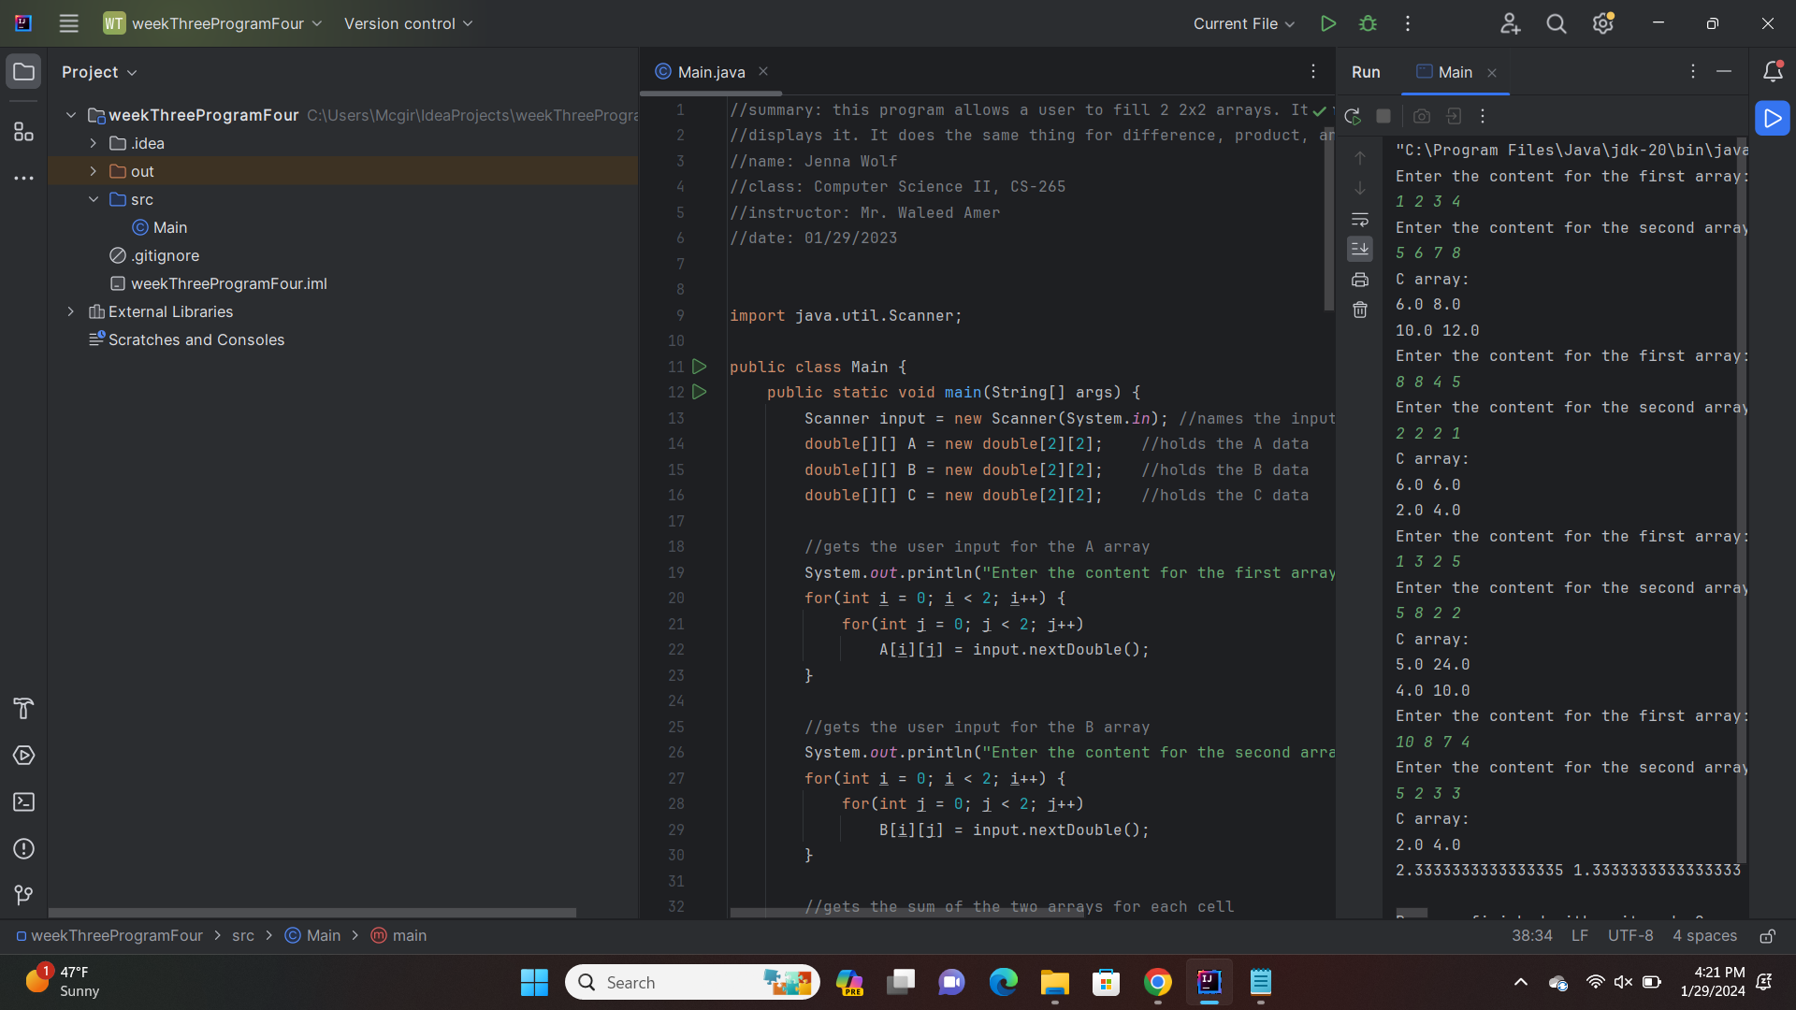

**Question 5: Write a program that will 1. Find the largest element of an array, 2. Find the largest element of a column, and 3. Find the largest element of a row.**

//summary: this program takes in array values from the user. It then allows them to choose from

//finding the biggest number 1. in the array, 2. in a specific column, or 3. in a specific row

//name: Jenna Wolf

//class: Computer Science II, CS-265

//instructor: Mr. Waleed Amer

//date: 01/29/2023

import java.util.Scanner;

public class Main {

public static void main(String[] args) {

Scanner input = new Scanner(System.in); //names the input

double[][] array = new double[3][3]; //holds the array data

int choice = 0; //holds the choice data

int search = 0; //holds the search data

//takes in array values from the user

System.out.println("Please enter the values for your 3x3 array");

for(int i = 0; i < 3; i++) {

for(int j = 0; j < 3; j++)

array[i][j] = input.nextDouble();

}

//goes until 4 is entered

do {

//gets choice from user

System.out.println("Pick an option: ");

System.out.println("1. Biggest number in array");

System.out.println("2. Biggest number in specific column");

System.out.println("3. Biggest number in specific row");

System.out.println("4. Quit");

System.out.print("Choice: ");

choice = input.nextInt();

//calls different methods based on choice.

if(choice == 1)

locateLargest(array);

else if(choice == 2) {

System.out.println("Which column would you like to search? ");

search = input.nextInt();

if(search > -1 && search < 3)

locateLargestInColumn(array, search);

else

System.out.println("Please enter a proper number next time!");

}

else if(choice == 3) {

System.out.println("Which row would you like to search? ");

search = input.nextInt();

if(search > -1 && search < 3)

locateLargestInRow(array, search);

else

System.out.println("Please enter a proper number next time!");

}

else if(choice != 4)

System.out.println("Please enter a proper number next time!");

}while(choice != 4);

}

public static void locateLargest(double [][] a) {

double largest = a[0][0]; //holds the largest data

int locRow = 0; //holds the locRow data

int locCol = 0; //holds the locCol data

//finds the largest number in the array

for(int i = 0; i < 3; i++) {

for(int j = 0; j < 3; j++) {

if(a[i][j] > largest) {

largest = a[i][j];

locRow = i;

locCol = j;

}

}

}

//displays the array and the largest number with its index

for(int i = 0; i < 3; i++) {

for(int j = 0; j < 3; j++)

System.out.print(a[i][j] + " ");

System.out.println();

}

System.out.println("The largest number in the array is " + largest);

System.out.println("This number is in row " + locRow + " and column " + locCol);

}

public static void locateLargestInColumn(double [][] a, int row) {

double largest = a[0][row]; //holds the largest data

int index = 0; //holds the index data

//finds the largest number in the column

for(int i = 1; i < 3; i++) {

if(a[i][row] > largest) {

largest = a[i][row];

index = i;

}

}

//displays the array and the largest number with its index

for(int i = 0; i < 3; i++) {

for(int j = 0; j < 3; j++)

System.out.print(a[i][j] + " ");

System.out.println();

}

System.out.println("The largest number in the column is " + largest);

System.out.println("This number is in row " + index);

}

public static void locateLargestInRow(double [][] a, int col) {

double largest = a[col][0]; //holds the largest data

int index = 0; //holds the index data

//finds the largest number in the row

for(int i = 1; i < 3; i++) {

if(a[col][i] > largest) {

largest = a[col][i];

index = i;

}

}

//displays the array and the largest number with its index

for(int i = 0; i < 3; i++) {

for(int j = 0; j < 3; j++)

System.out.print(a[i][j] + " ");

System.out.println();

}

System.out.println("The largest number in the row is " + largest);

System.out.println("This number is in column " + index);

}

}

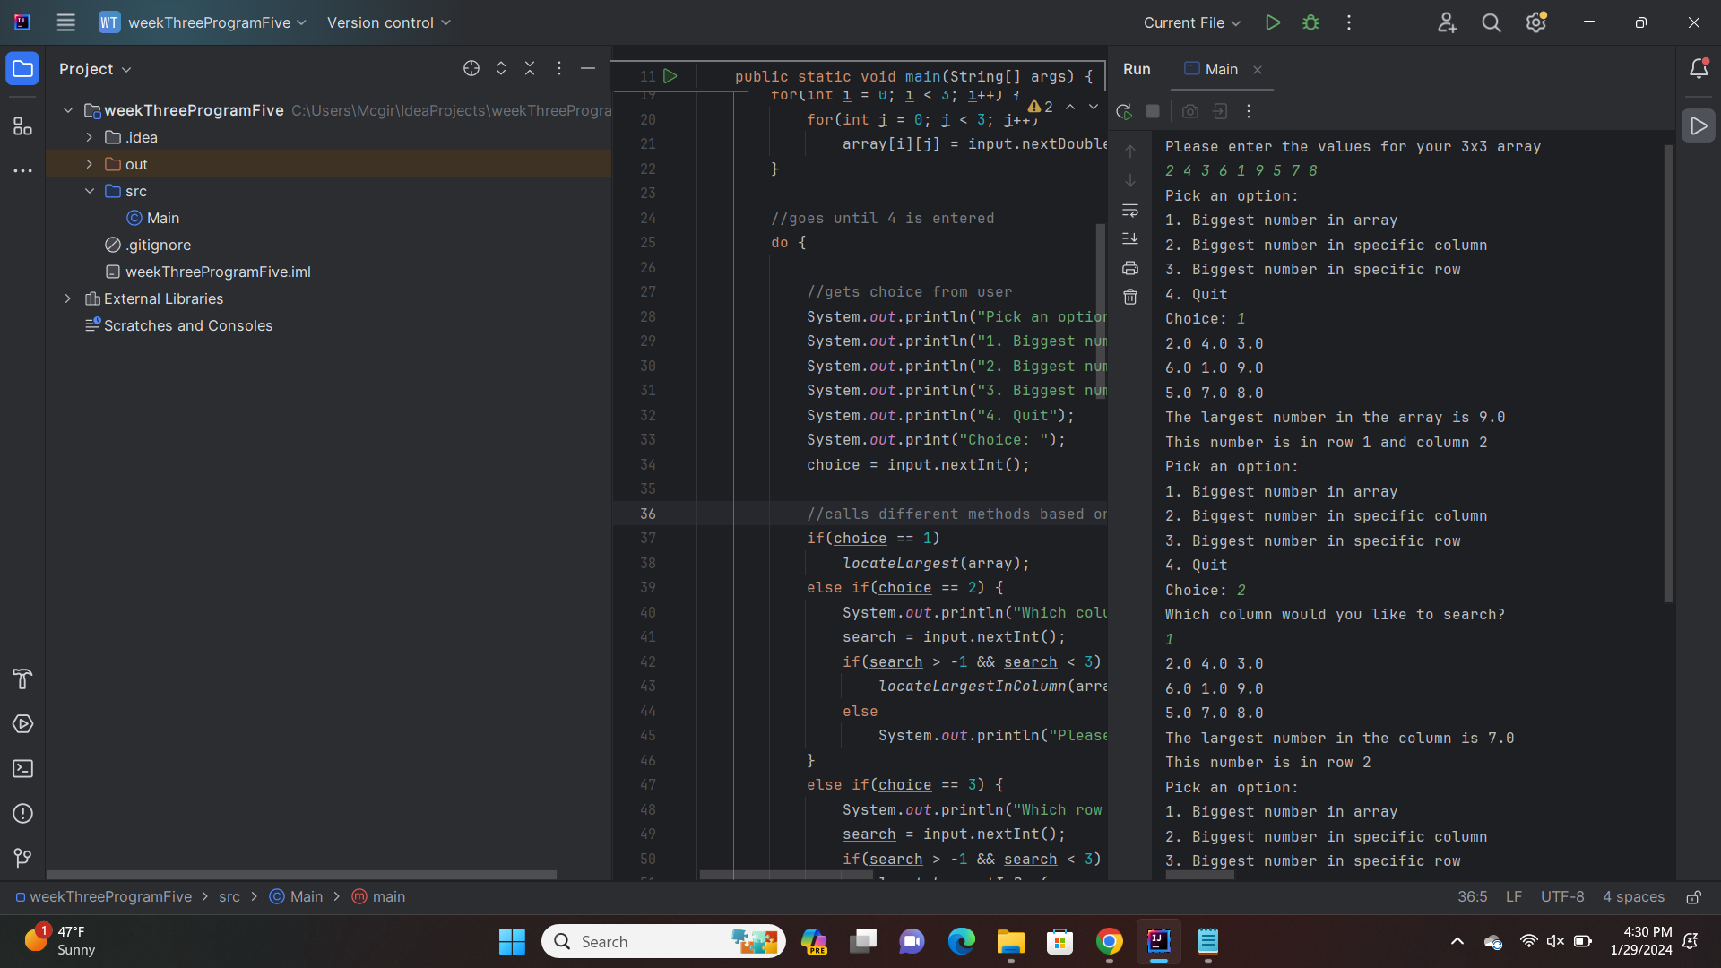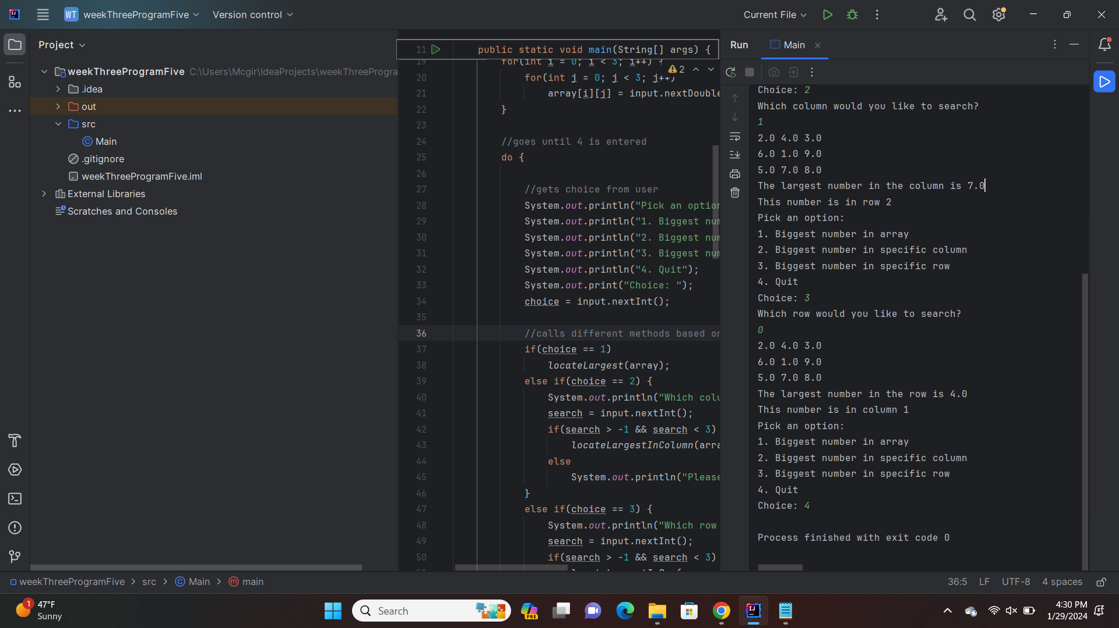

**Question 6: Write a program to sort the content of columns in a 2D array. The values stored in each column will be sorted ascendingly.**

//summary: this program displays an array in ascending order based on each column

//name: Jenna Wolf

//class: Computer Science II, CS-265

//instructor: Mr. Waleed Amer

//date: 01/29/2023

public class Main {

public static void main(String[] args) {

double[][] array = { {5, 3, 8}, {2, 1, 6}, {3, 2, 1} }; //holds the array data

double temp = 0; //holds the temp data and is set to 0

//displays the array

for(int i = 0; i < 3; i++) {

for(int j = 0; j < 3; j++)

System.out.print(array[i][j] + " ");

System.out.println();

}

//sorts the array into ascending order by each column

for(int i = 0; i < 3; i++) {

for(int j = 2; j > 0; j--) {

for(int n = 0; n < j; n++) {

if(array[n][i] > array[n + 1][i]) {

temp = array[n][i];

array[n][i] = array[n + 1][i];

array[n + 1][i] = temp;

}

}

}

}

//displays the array

System.out.println();

for(int i = 0; i < 3; i++) {

for(int j = 0; j < 3; j++)

System.out.print(array[i][j] + " ");

System.out.println();

}

}

}

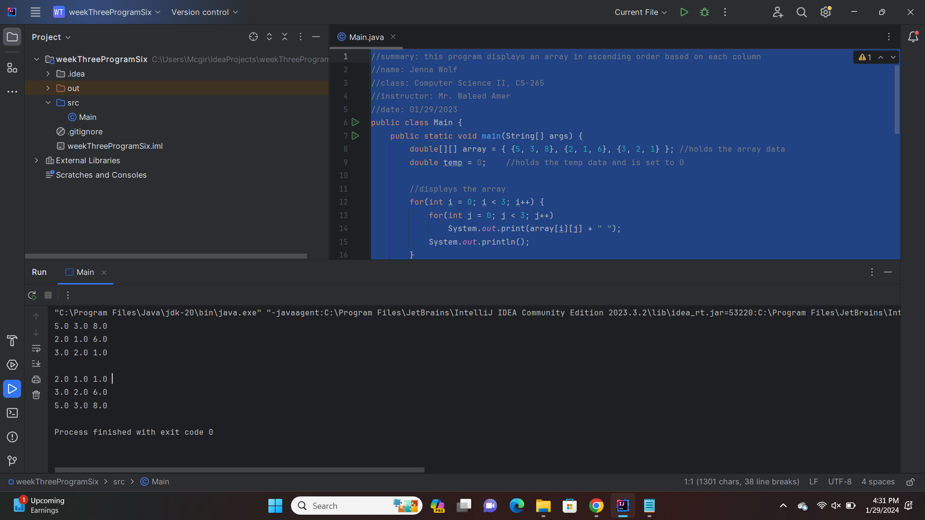

**Question 7: Write a program that will read the content of 2 2D arrays and displays whether the two are identical. Two arrays are identical if they have the same content AND in the same order.**

//summary: this program allows the user to enter values into 2 2x2 arrays. It then checks to

//see if they are even based on values and positions.

//name: Jenna Wolf

//class: Computer Science II, CS-265

//instructor: Mr. Waleed Amer

//date: 01/30/2023

import java.util.Scanner;

public class Main {

public static void main(String[] args) {

Scanner input = new Scanner(System.in); //names Scanner input

double[][] arrayOne = new double[2][2]; //holds the arrayOne data

double[][] arrayTwo = new double[2][2]; //holds the arrayTwo data

boolean check = true; //holds the check data

//fills arrayOne with user input

System.out.println("Enter your values for your first array");

for(int i = 0; i < 2; i++) {

for(int j = 0; j < 2; j++)

arrayOne[i][j] = input.nextDouble();

}

//fills arrayTwo with user input

System.out.println("Enter your values for your second array");

for(int i = 0; i < 2; i++) {

for(int j = 0; j < 2; j++)

arrayTwo[i][j] = input.nextDouble();

}

//checks to see if values are the same in each array

for(int i = 0; i < 2; i++) {

for(int j = 0; j < 2; j++) {

if(arrayOne[i][j] != arrayTwo[i][j]) {

check = false;

i = 2;

j = 2;

}

}

}

//displays a message based on the value of check

if(check)

System.out.println("Arrays are equal");

else

System.out.println("Arrays are not equal");

}

}

